Technical Story Card

Revision History
Version No. | Date | Prepared by / Modified by | Significant Changes

Glossary
Abbreviation | Description
BSC | Business Story Card
TSC | Technical Story Card

Table of Contents
1 Introduction 3
2 Scope of Change 3
3 List of impacted modules 3
4 Design and Detailed technical updates 4
4.1 Process model 4
4.1.1 Use case Model 4
4.1.2 Sequence diagram 4
4.2 Proposed user Interface design 4
4.3 Database design changes 4
4.4 Refactoring related changes 4
4.5 Construction strategy and re-use 4
5 Details of Alternative Design Approach 4
6 Other Technical changes 5
6.1 Automation tasks / changes 5
6.2 CI / Build relates tasks / changes 5
6.3 Non-functional related changes 5
7 Additional details 5
7.1 Open Questions / clarifications / Assumptions 5
7.2 Additional notes to technical team 5
8 References 5

Introduction
This is a management system that will be going to implement to make the tasks easy for management. There will be 3 main users for this system they are admin, users and librarian. The librarian is in charge of maintaining the system. Some of the key roles that the librarian will do is, add a new book, update an existing book or delete a current book from the system. Via the system a user will be able to reserve a book, renew a book, look for the fine that they need to pay. To access these features every user needs to create an account to access these features, without a valid username and password they won't be able to access the system

Scope of Change
<Mention the scope of changes; if any related story also impacted, mention the details>

List of impacted modules
<Document the modules impacted with brief description of changes to be done >

Design and Detailed technical updates
<Provide details of the Design/approach for developing/implementing the requirements>

Process model

Use case Model

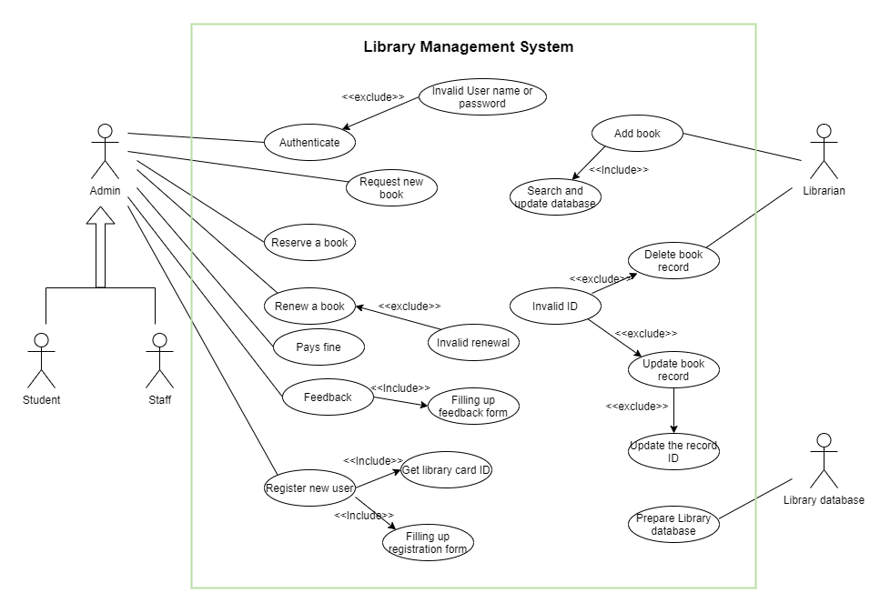

Brief Description | User Registration
Basic Flow | This use case describes how a staff or student can register in to the system  - The user has to fill in the registration form.  - The following information is required during registration.  - Name  - Address  - Email  - Mobile Number  - NIC  - Date of birth  - Password  - Account type (Staff/customer)  - If account type is staff, should input employee ID  - Once the user has successfully registered, a library card ID will be issued.  - People under 18 will not be allowed to restricted content.
Alternate Flow | - The system will validate the information provided. If any of the inputted data doesn’t match the requirements, the user will be notified with a popup message.
Validation | - Name is required and minimum 3 characters and max 50 characters.  - The address can be alphanumeric.  - Email address is required  - Mobile number is required  - NIC is required.  - Date of birth is required.  - The password should have at least one capital and one simple letter, numbers and at least one special character.  - Employee ID is required if staff account type.
Pre-Conditions | User should have network access and browser with the latest updates.
Post-Conditions | Success message should be shown.

Brief Description | User Authentication
Basic Flow | This use case describes how a staff or student can log in to the system with their credentials  - The user has to enter their username and password  - Once the user has successfully authenticated, a success message will appear and the user will be directed to the appropriate landing page.
Alternate Flow | - The system will validate the information provided. If the user inputs an incorrect username or password, the system will prompt the user with a popup message.
Validation | - Correct username and password
Pre-Conditions | User should already be registered in the system
Post-Conditions | Success message should be shown.

Brief Description | Reserve a book
Basic flow | This use case describes how a user can reserve a book,  - User logins to the system with valid username and password  - Selects the option reserve a book  - Enters the relevant information like BookID, Book name, reservation date, reservation time  - Clicks submit button a successful message will be displayed
Alternative flow | - If password and username doesn’t match displays error.  - The system will validate the data. If incorrect data is provided an error message will display
Validation | - Book ID is alphanumeric.  - Book names can’t be empty.  - Reservation date and reservation time can’t be null.
Pre-condition | Need to be registered with the system
Post- Condition | A successful message will be displayed.

Brief Description | Renew a book
Basic flow | This use case describes how a user can Renew a book  - User logins to the system with valid username and password  - Selects the option to renew a book  - Enters the relevant information like Book ID, Book name, renew date.  - Clicks submit a successful message will be displayed
Alternative flow | - If password and username doesn’t match displays error.  - The system will validate the data if incorrect data is provided an error message will display
Validation | - Book ID is alphanumeric.  - Book names can’t be empty.  - The new date can’t be null and can’t be less than the current date.
Pre-condition | Need to be registered with the system
Post- Condition | A successful message will be displayed.

Brief Description | Feedback
Basic flow | This use case describes how a user can give feedback  - User logins to the system with valid username and password  - Selects the option feedback  - Enters the relevant information like user ID, name, feedback.  - Clicks submit button a successful message will be displayed
Alternative flow | - If password and username doesn’t match displays error.  - The system will validate the data if incorrect data is provided an error message will display
Validation | - User ID can't be empty  - User name can’t be empty.
Pre-condition | Need to be registered with the system
Post- Condition | A successful message will be displayed.

Brief Description | Request for a new book
Basic flow | This use case describes how a user can request a new book  - User logins to the system with valid username and password  - Selects the option request new book  - Enters the relevant information like Book ID, Book name, Request Date, username.  - Clicks submit button a successful message will be displayed
Alternative flow | - If password and username doesn’t match displays error.  - The system will validate the data if incorrect data is provided an error message will display
Validation | - Book ID can’t be empty  - Book names can’t be empty.  - Request date should be entered as a date format  - Username can’t be empty
Pre-condition | Need to be registered with the system
Post- Condition | A successful message will be displayed.

Brief Description | Delete a new book
Basic flow | This use case describes how a Librarian/ admin can delete a book  - User logins to the system with valid username and password  - Selects the option to delete a book  - Enters the relevant information like Book ID, Book name.  - Clicks submit button a successful message will be displayed
Alternative flow | - If password and username doesn’t match displays error.  - the system will validate the data if incorrect data is provided an error message will display
Validation | - Book ID can’t be empty  - Book names can’t be empty.
Pre-condition | Need to be registered with the system as an admin or librarian.
Post- Condition | A successful message will be displayed.

Brief Description | Update a book
Basic flow | This use case describes how a Librarian/admin can update a book  - User logins to the system with valid username and password.  - Selects the option to update a book.  - Enters the relevant information like Book ID, Title, author, Publisher, Date of modified, Language.  - Clicks submit button a successful message will be displayed
Alternative flow | - If password and username doesn’t match displays error.  - The system will validate the data if incorrect data is provided an error message will display.
Validation | - Book ID can’t be empty.
Pre-condition | Need to be registered with the system as an admin or librarian.
Post- Condition | A successful message will be displayed.

Brief Description | Returning book
Basic Flow | This use case describes how a student returns a book on time  - After the successful return book, student will get a successful message  - The following information is required  - Name  - Address  - Email  - Mobile  - Borrowing date  - Returning date
Alternate Flow | The system will validate the information provided. If any invalid data is found, the input form will be redirected with error message.
Validation | - Name is required and minimum 3 characters and max 50 characters.  - Address can be alphanumeric  - Mobile should be 10 numeric  - The Email should be valid.  - Borrowing date should be d/m/y format  - Returning date should be d/m/y format
Pre-Conditions | - User should have network access and Browser with latest updates  - A little bit of knowledge about IT
Post-Conditions | A successful message should be shown

Brief Description | Adding Book Details to the System
Basic Flow | This use case describes how a staff member (admin) inserts new book details into the system  - The Admin has to login to the system.  - The Following information is required during adding the new book to the system.  - ISBN  - Title  - Category  - Author  - Publisher  - Quantity  - Date of modified  - On Loan  - Language
Alternative Flow | The system will validate the information provided. If any duplicates details found. System will give an error message.
Validation | - Book Code (ISBN) should be valid
Pre-Conditions | User should have already logged into the system
Post-Conditions | Success message should be shown.

Sequence diagram
<Update the sequence diagram on how processes operate with one another and in what order and intent of changes / requirements proposed in the story >

Proposed user Interface design
<Document the various interfaces available to the user through this story and module>

Database design changes
<Provide the logical design of the base data structures used to store the data. E.g. Like tables, and views or entities and relationships>

Refactoring related changes
<Mention details of code re-factoring requirements; objective and scope of re-factoring and Changes to be done >

Construction strategy and re-use
< Mention about automated code development (using code-generator) or manual coding. Also identify make/buy/reuse components involved, if any >

Details of Alternative Design Approach
<Details of the alternative approach to resolve the maintenance request>

Other Technical changes

Automation tasks
<if the story is about automation (of test cases or some POC etc.), mention the details here>

CI / Build relates tasks
<If the story requirements are about implementation of continuous integration or build, update the details to be done here>

Non-functional related changes
<Non-functional requirements related to response time, System load or Network load>

Additional details

Open Questions / clarifications / Assumptions
<Mention the details of any open technical questions/clarifications or assumptions made, pertaining to story >

Additional notes to technical team
<provide details if any>

References
< Provide reference details if any >

